In this article, let us review the Linux filesystem structures and understand the meaning of individual high-level directories.  
  
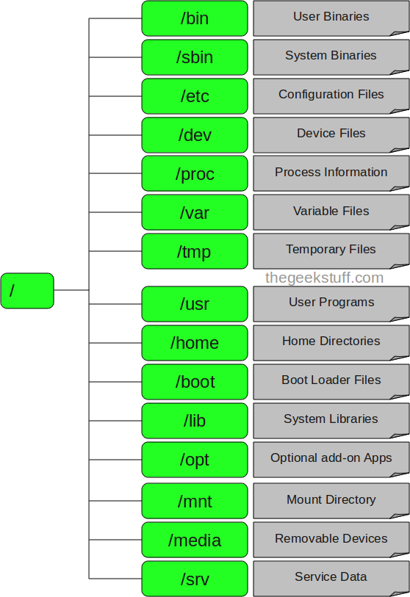

1. / – Root

* Every single file and directory starts from the root directory.
* Only root user has write privilege under this directory.
* Please note that /root is root user’s home directory, which is not same as /.

2. /bin – User Binaries

* Contains binary executables.
* Common linux commands you need to use in single-user modes are located under this directory.
* Commands used by all the users of the system are located here.
* For example: ps, ls, ping, grep, cp.

3. /sbin – System Binaries

* Just like /bin, /sbin also contains binary executables.
* But, the linux commands located under this directory are used typically by system aministrator, for system maintenance purpose.
* For example: iptables, reboot, fdisk, ifconfig, swapon

4. /etc – Configuration Files

* Contains configuration files required by all programs.
* This also contains startup and shutdown shell scripts used to start/stop individual programs.
* For example: /etc/resolv.conf, /etc/logrotate.conf

5. /dev – Device Files

* Contains device files.
* These include terminal devices, usb, or any device attached to the system.
* For example: /dev/tty1, /dev/usbmon0

6. /proc – Process Information

* Contains information about system process.
* This is a pseudo filesystem contains information about running process. For example: /proc/{pid} directory contains information about the process with that particular pid.
* This is a virtual filesystem with text information about system resources. For example: /proc/uptime

7. /var – Variable Files

* var stands for variable files.
* Content of the files that are expected to grow can be found under this directory.
* This includes — system log files (/var/log); packages and database files (/var/lib); emails (/var/mail); print queues (/var/spool); lock files (/var/lock); temp files needed across reboots (/var/tmp);

8. /tmp – Temporary Files

* Directory that contains temporary files created by system and users.
* Files under this directory are deleted when system is rebooted.

9. /usr – User Programs

* Contains binaries, libraries, documentation, and source-code for second level programs.
* /usr/bin contains binary files for user programs. If you can’t find a user binary under /bin, look under /usr/bin. For example: at, awk, cc, less, scp
* /usr/sbin contains binary files for system administrators. If you can’t find a system binary under /sbin, look under /usr/sbin. For example: atd, cron, sshd, useradd, userdel
* /usr/lib contains libraries for /usr/bin and /usr/sbin
* /usr/local contains users programs that you install from source. For example, when you install apache from source, it goes under /usr/local/apache2

10. /home – Home Directories

* Home directories for all users to store their personal files.
* For example: /home/john, /home/nikita

11. /boot – Boot Loader Files

* Contains boot loader related files.
* Kernel initrd, vmlinux, grub files are located under /boot
* For example: initrd.img-2.6.32-24-generic, vmlinuz-2.6.32-24-generic

12. /lib – System Libraries

* Contains library files that supports the binaries located under /bin and /sbin
* Library filenames are either ld\* or lib\*.so.\*
* For example: ld-2.11.1.so, libncurses.so.5.7

13. /opt – Optional add-on Applications

* opt stands for optional.
* Contains add-on applications from individual vendors.
* add-on applications should be installed under either /opt/ or /opt/ sub-directory.

14. /mnt – Mount Directory

* Temporary mount directory where sysadmins can mount filesystems.

15. /media – Removable Media Devices

* Temporary mount directory for removable devices.
* For examples, /media/cdrom for CD-ROM; /media/floppy for floppy drives; /media/cdrecorder for CD writer

16. /srv – Service Data

* srv stands for service.
* Contains server specific services related data.
* For example, /srv/cvs contains CVS related data.